What is a Machine Learning Model? 

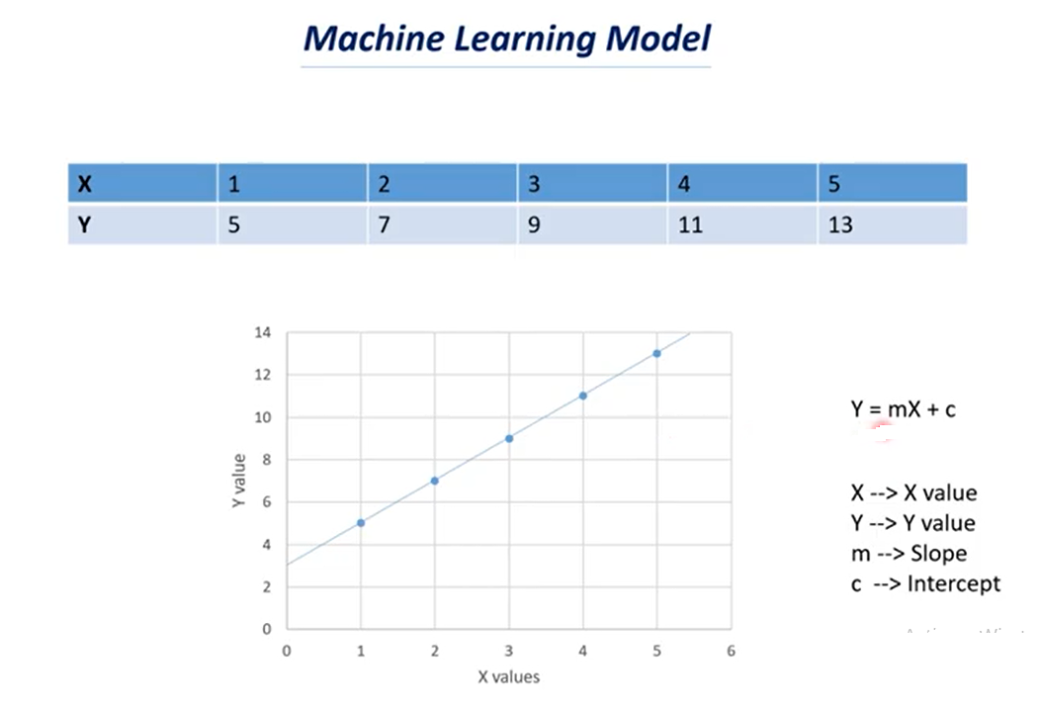

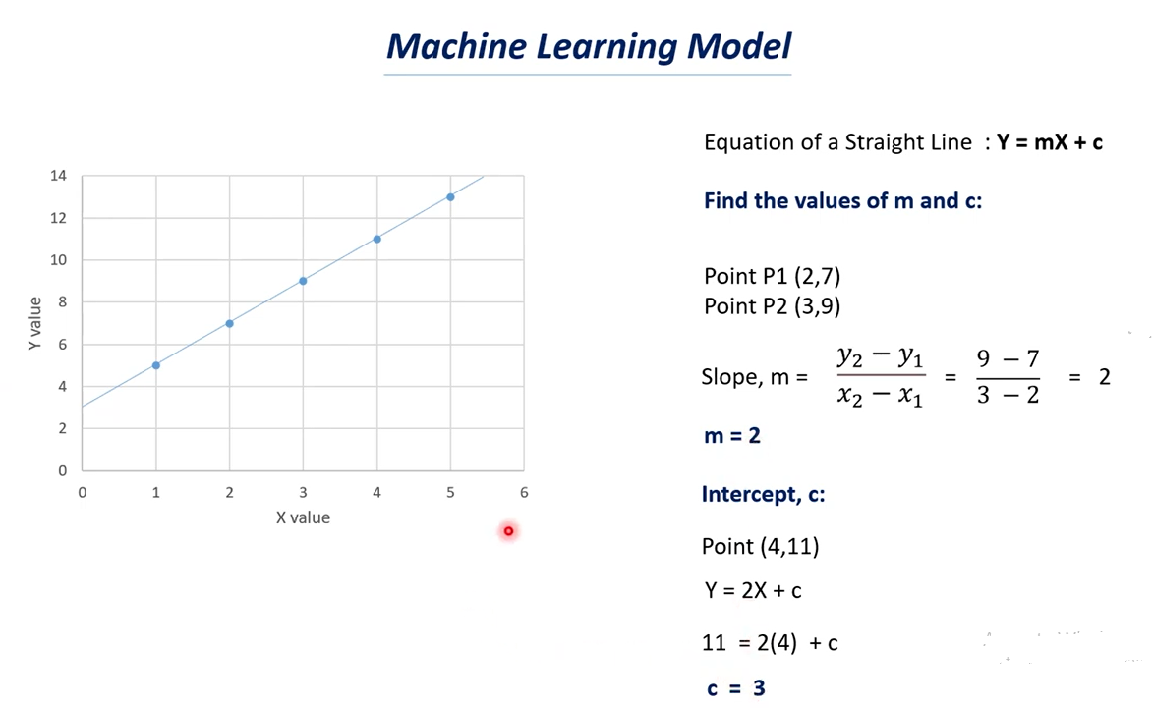

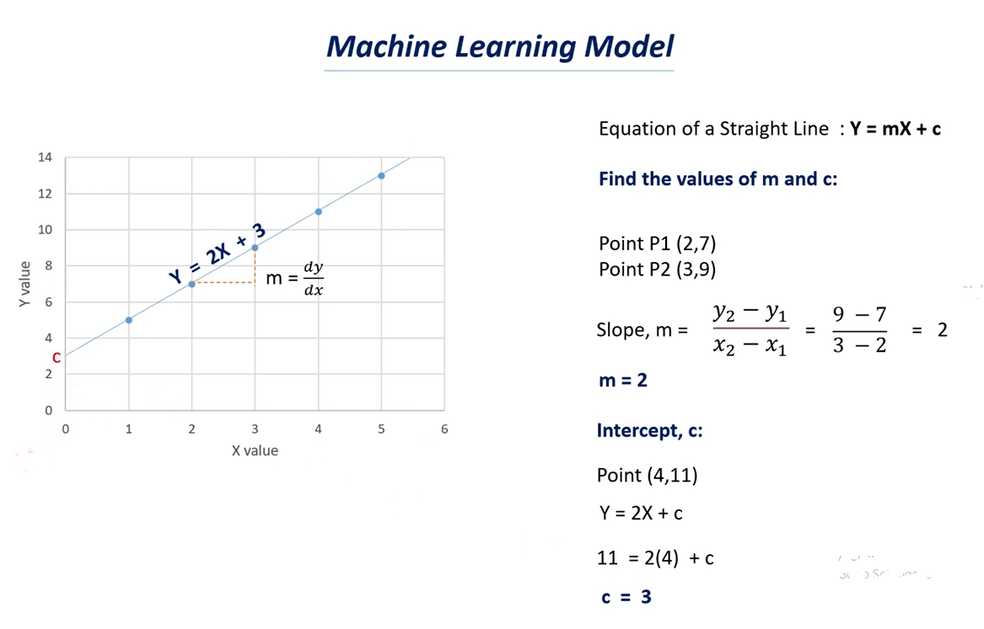

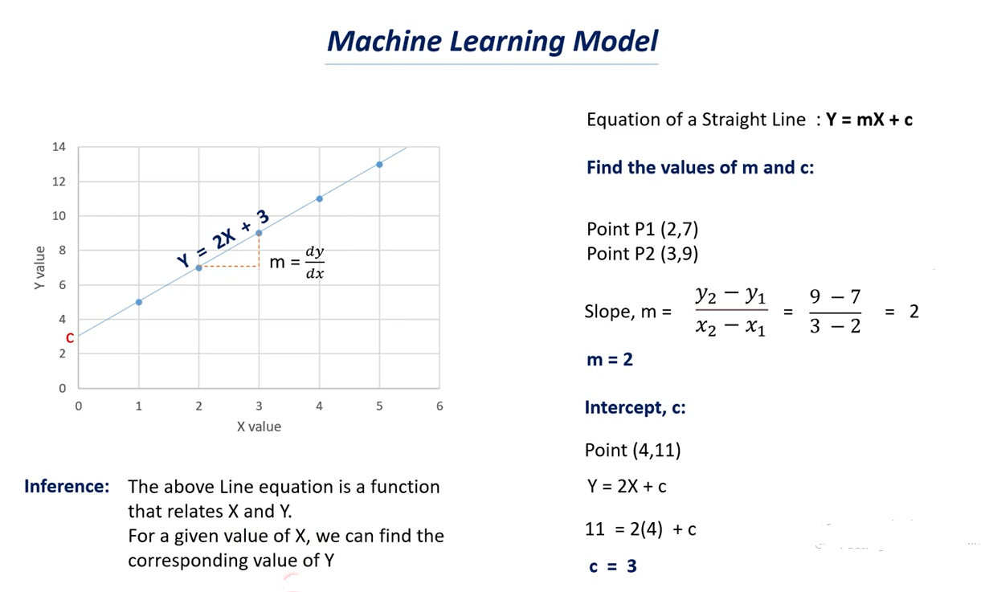

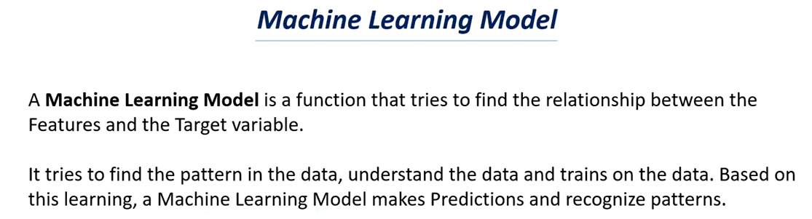

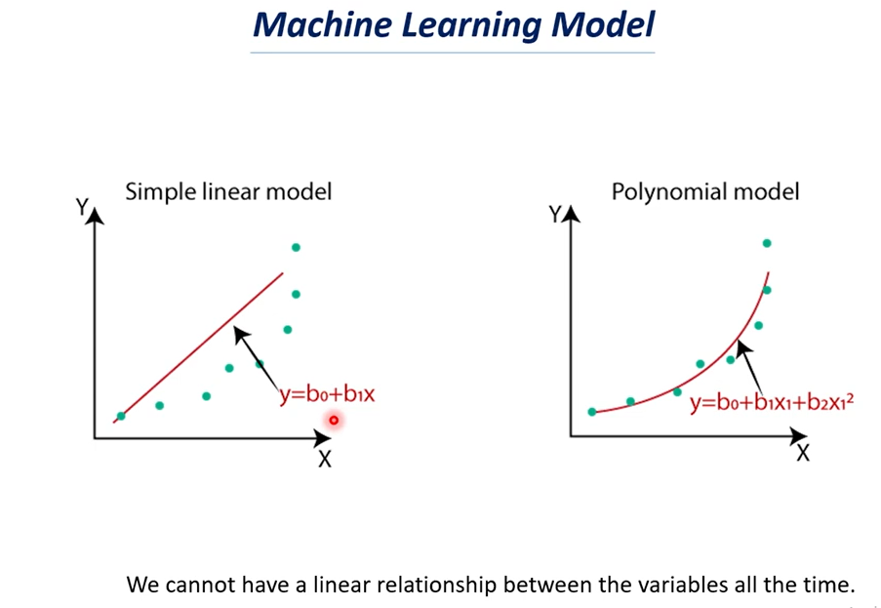

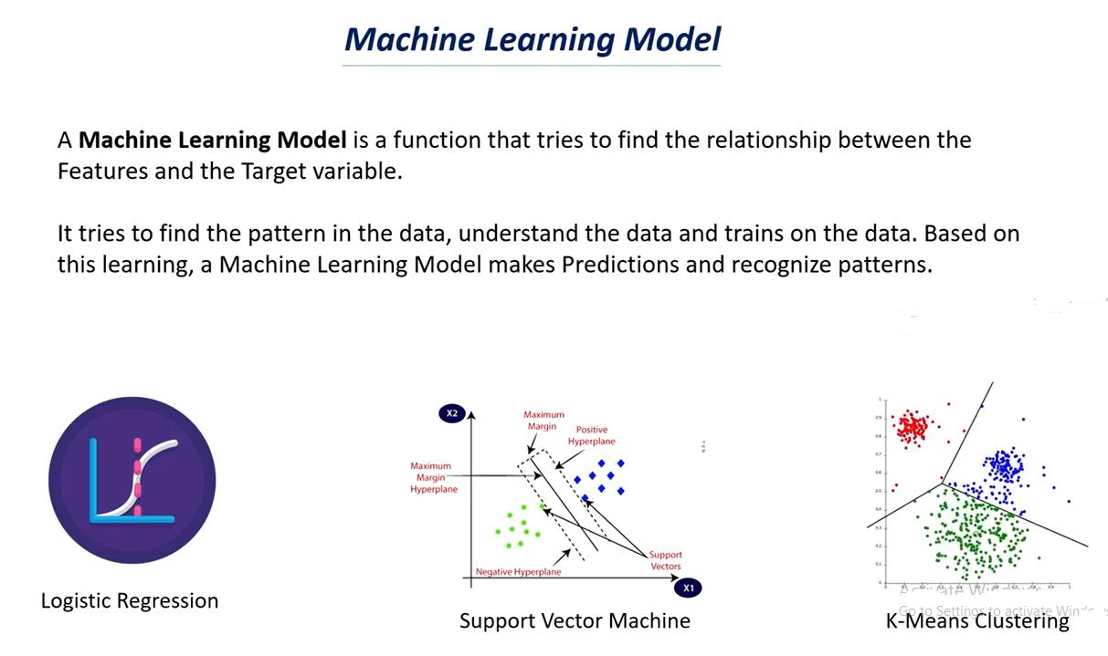

# Supervised Learning Models | Supervised Learning

# 

# 

# 

# 

# Unsupervised Learning Models | Unsupervised Learning

# 

# 

# 

# 

# 

# How to choose the right Machine Learning Model ,Model Selection ,Cross Validation

# 

# 

# 

# 

# 

# 

# 

# 

# Over fitting in Machine Learning:

# The Model over trained on the training data points.

# We have X values and Y Values and we have these many datapoints.

# We try to fit the curve to these data points.

# It is an optimal Model.

# It will try to find the common trends in it,

# If the model is over fitted we will get a curve something like this above.

# Here the curve try’s to join all the data points.

# In first case it is the regular curve.

# In second case the curve try’s to join all the data points.

# The over fit model try’s to model the data too well which means it tries to fit to all the data points, Here we can’t have a regular curve.

# Note: when we don’t get a regular curve we can’t make a good prediction out of it.

# In case of optimal model we have generalized curve or generalized mode.

# In case of over fit model we don’t have a generalized curve as we observed we have rises and dips in the curve

# If you see the data points in both the graphs are same but curves are different i.e over trained of the data.

# In case of over fit when a model learns the details and noise in the training dataset.

# Noises can be outliers and some data points that don’t make sense.

# Note: The good model try’s to ignore these noises that are presents in the dataset.

# In case of optimal it tries to find a generalized value.

# In case of over fit it tries to pick all the data points which can be noise.

# Sign that the model has over fit:

# The accuracy on the training data will be very high and the accuracy on the test data will be very low.

# That why we try to find the accuracy score for both training data and test data as well.

# If the accuracy of training data & test data is the same let’s say accuracy of the training data is 85% and the accuracy of the test data is 83% its almost similar.

# In this case we can say the model is optimal.

# Suppose the accuracy of the training data is 95% and the accuracy of the test data is 30% or 40% then we say that the model is over fitted.

# When the model tries to fit to all the data points it can’t give generalization and it can’t be reliable to make prediction out of it.

# 

# 

# 

# As we have discuss less data causes over fitting and if we have large dataset then the model ignores the outliers most of the time.

# It can understand the data better if it have more data so it is very important concept in machine learning and deep learning as well.

# More the data better the performance of the model is.

# If you have more data than the chances of over fitting is very less.

# Reduce the number of layers in the neural network as we discuss increase of layers in the neural network that causes over fitting so we need to reduce the number of layers.

# Early stopping: Early stopping is a technique that is used in machine learning what happened in machine learning is that in machine learning we iterate the data multiple times so the model tries to learn from the data multiple times this is called as iteration because it does the same thing again and again.

# So when we do early stopping technique the model tries to stop learning once it is over fitted.

# If over fit start it stop the training part this is called early.

# Bias – Variance tradeoff it is the most important topic in machine learning .

# Bias-variance tradeoff is used to find the optimal model for a dataset.

# This is used for a model optimization technique.

# Dropouts: if we have dropouts some neurons will be dropout randomly and some neurons will be turned on randomly and this stop the problem of over fitting.

# As we have less neuron the complexity of the model reduced.